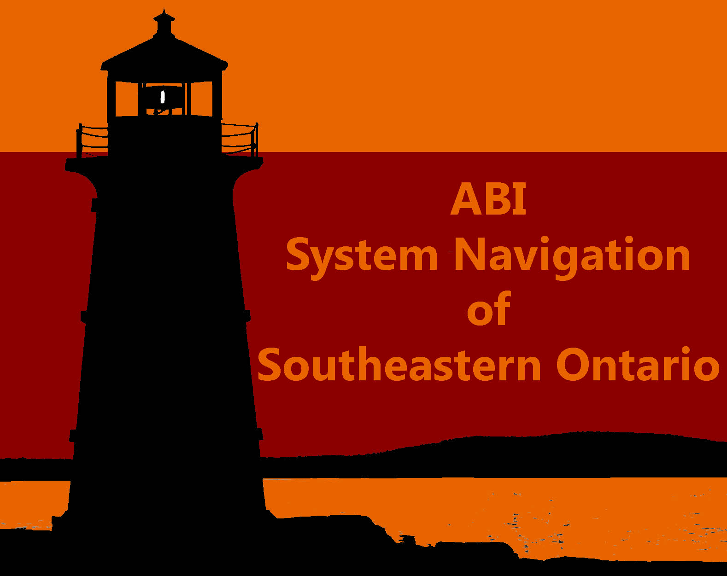
Top 10 Challenges to Meeting ABI Survivors’ Needs
Registration Form

Please Select the Date and Location of the Event you Wish to Attend:
May 24, 2012 in Belleville
June 8, 2012 in Brockville
June 14, 2012 in Kingston

Name:
Email:
Job Title:
Organization:
Address:
Phone:
Do you wish to be added to our mailing list?

Please submit by email to henryr1@providencecare.ca
Or fax to 613-547-6472

Thank you!

