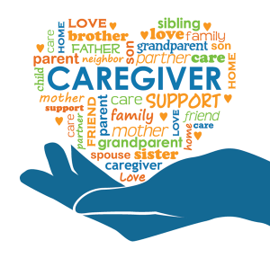
Caregiver Tips and Resources

When your family member was diagnosed with a brain injury, you may have received a lot of information about the impact of the injury on their physical, cognitive and mental health. While it is natural for the focus of care to be on the individual with the injury, a brain injury does affect a wider circle of care, including family and friends. Being a primary caregiver for someone with a long-term injury, such as a brain injury, can take a toll on one’s physical and mental health and wellbeing. As such, it is important to ensure that you are taking care of yourself and know where to turn for help.

Below is a list of tips and resources that you may find helpful whether you are caring for a parent, spouse, sibling, child or other relation.

Ontario Brain Injury Association
https://caregiverinfo.ca/
Helpline 1-800-263-5404 Mon to Fri 9:30am to 4:00pm

Ontario Caregiver Organization
https://ontariocaregiver.ca/
Helpline for 24/7 support 1-833-416-2273 (CARE)

Petro Canada CareMaker’s Foundation
https://www.caremakers.ca/en?gclid=EAIaIQobChMIi7OYsMb78AIV0xmtBh1C9AIxEAAYAiAAEgKHLvD_BwE&gclsrc=aw.ds

Self-Care for Caregivers
https://www.canada.ca/en/public-health/services/reports-publications/responding-stressful-events/self-care-caregivers.html

Brainline
https://www.brainline.org/caregivers

Respite Services
https://www.respiteservices.com/

HealthLine Ontario
https://www.thehealthline.ca/

Caregiving Benefits
https://www.canada.ca/en/services/benefits/ei/caregiving.html
Caregiver Action Network
https://caregiveraction.org/
